**What’s Happening During Convection?**

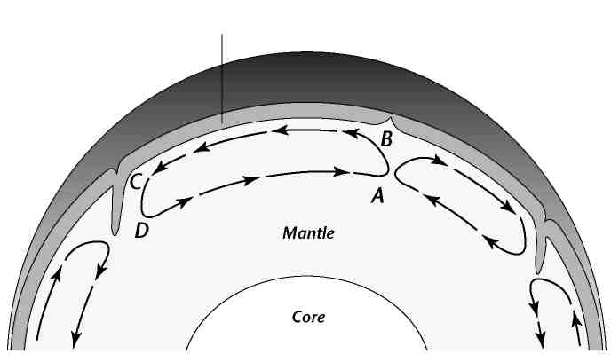

***Lithosphere***

The figure below shows a convection cell in Earth’s mantle.

A **convection cell** is one complete loop of a convection current.

Use the figure to answer the questions that follow.

1. Where does the heat come from that drives this convection current?
2. Where is the temperature of the material in the mantle greater, at point A or point B? Explain why.
3. Where is the density of the material greater, at point B or point C? Explain why.
4. What causes the convection cell to turn to the left at point B?
5. What happens to the temperature and density of the material between points B and C?
6. What force causes the convection cell to turn down at point C?
7. What happens to the temperature and density of the material between points D and A?
8. What causes the convection cell to turn up at point A?
9. How do you think this convection cell might affect the crust material above it?

|  |  |  |  |  |
| --- | --- | --- | --- | --- |
| titleplatetectonics | Name: __________________________ | | | |
| Y  T  T  I  I  C | |  | **Across**  **3.** The zone below the lithosphere. It is more 'plastic' than the lithosphere so it is easier to bend and move.  **6.** The most outer solid portion of the planet Earth.  **8.** The outer part of the Earth's crust. It is composed of solid rock.  **10.** Places where new seafloor is being created.  **12.** The deepest parts of the oceans.  **14.** The Theory of Continental _____________.  **15.** The Earth's ______________ field reverses from time to time.  **16.** Alfred Wegener noticed that the coast of South America seemed to fit into the coast of this continent, just like a jigsaw puzzle.  **17.** Scientist who first proposed the theory that the continents drifted. | |
| **Down**  **1.** The primary force that causes the seafloor to spread and continents to drift.  (Hint: Starts with a “T”… See also #13 down clue)  **2.** Plate _____________.  **4.** ______________ zones. Places where the seafloor is forced under continental plates.  **5.** Section of the Earth below the crust.  **7.** Paleontologists noticed that these were the same on different continents even though the continents were separated by oceans.  **9.** Source of heat in the mantle.  (Hints: Starts with something you listen to in the car, and, it ends  in –ity)  **11.** Seafloor ______________.  **13.** Scientist who first proposed that thermal convection in the mantle causes continental drift. (Hint: Sherlock…_____) | | | | continentaldrift |